PIICH Storyboard Contest
Storyboard Template

In crafting a storyboard, each panel on the left represents a segment of the 2-minute video. You may illustrate by hand, drawing software, computer device, and/or photos. Use the panel on the right to describe the corresponding segment. The goal is to communicate your ideas thoroughly to the judges. Use as many panels as necessary.

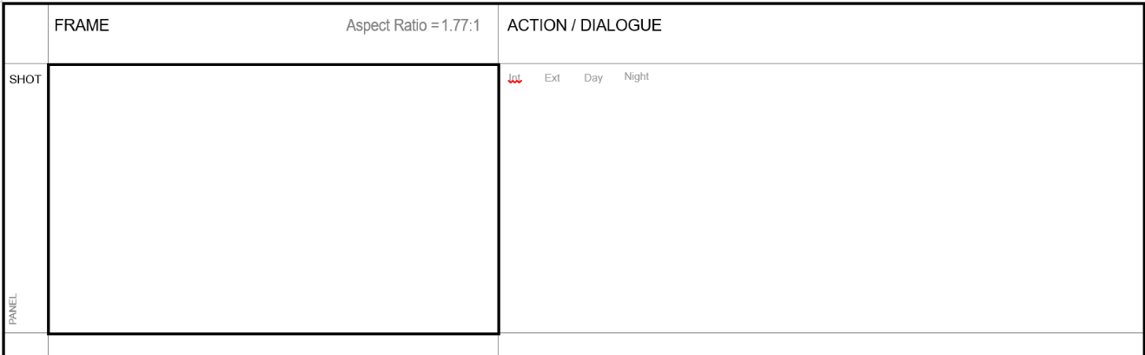
In the right panel, write a description of the action happening in the drawing.

Add narration or dialogue that corresponds to the scene.
Draw in the left panels.

 | FRAME Aspect Ratio = 1.77:1 | ACTION / DIALOGUE
PANEL
PANEL
PANEL
PANEL

 | FRAME Aspect Ratio = 1.77:1 | ACTION / DIALOGUE
PANEL
PANEL
PANEL
PANEL

